

INSTITUTE OF SOFTWARE TECHNOLOGIES

Pscanner
( PORT SCANNING TOOL )

DIPLOMA IN CYBERSECURITY AND ETHICAL HACKING

2024

DECLARATION.

It is declared that the project titled PScanner is originally proposed by me.
However, further research and exploration onto this project is granted and encourage for contribution upon this topic.

Abubakar Abdallah Abubakar

Date: ……………………..

3

CONFIRMATION

This project entitle Pscanner was prepared and submitted by an IST student that
has been satisfactory in terms of scope, quality and presentation as a partial fulfilment of the requirement for Diploma In Cybersecurity and Ethical Hacking in the Institute of Software Technologies

Signature: ……………………………..

Supervisor: ……………………………

Date: ………………………………….

4

DEDICATION

I would like to thanks to my supervisor who had guided me, give valuable information and give useful suggestion during compilation and preparation of this research. Also thanks to my family and friends at the instigation of the completion of this project.

5

Table of Contents

DECLARATION 3
CONFIRMATION 4
DEDICATIONS 5
Table of Contents 6
CHAPTER ONE 7
Abstract 7
Background 8
Objective 9
Project Scope 10

CHAPTER TWO 11
Introduction 11
Overview 12

CHAPTER THREE 13
Methodology 13

CHAPTER FOUR 16
System Analysis and Design 16

CHAPTER FIVE 26
Code Analysis 26

SUMMARY 30

REFERENCES 31

6

CHAPTER ONE

Abstract:

- Port scanning tools are fundamental instruments in the field of Cybersecurity, serving a variety of purposes ranging from network reconnaissance to vulnerability assessment and penetration testing. These tools operate by systematically probing target systems to identify open ports and services, providing valuable insights into network topology, security vulnerabilities, and potential attack vectors.
- This abstract explores the significance of port scanning tools in modern Cybersecurity practices, examining their roles, methodologies, and main objectives. By understanding the capabilities and applications of port scanning tools, organizations can effectively strengthen their security posture and mitigate the risks posed by Cyber threats.

7

Background:

- Port scanning tools are software applications designed to explore and analyze the open ports on a networked system. Ports act as endpoints for communication within a network, with each port assigned a specific number and protocol for different types of services. Understanding the status of these ports is crucial for network administrators and Cybersecurity professionals to assess the security posture of their systems.

- Port scanning tools operate by sending specially crafted packets to the target system's IP address, attempting to establish a connection with various ports. Based on the response received, these tools determine whether a port is open, closed, or filtered (blocked by a firewall). The information gathered from port scans helps identify potential entry points for attackers, as well as weaknesses in network configurations or firewall rules.

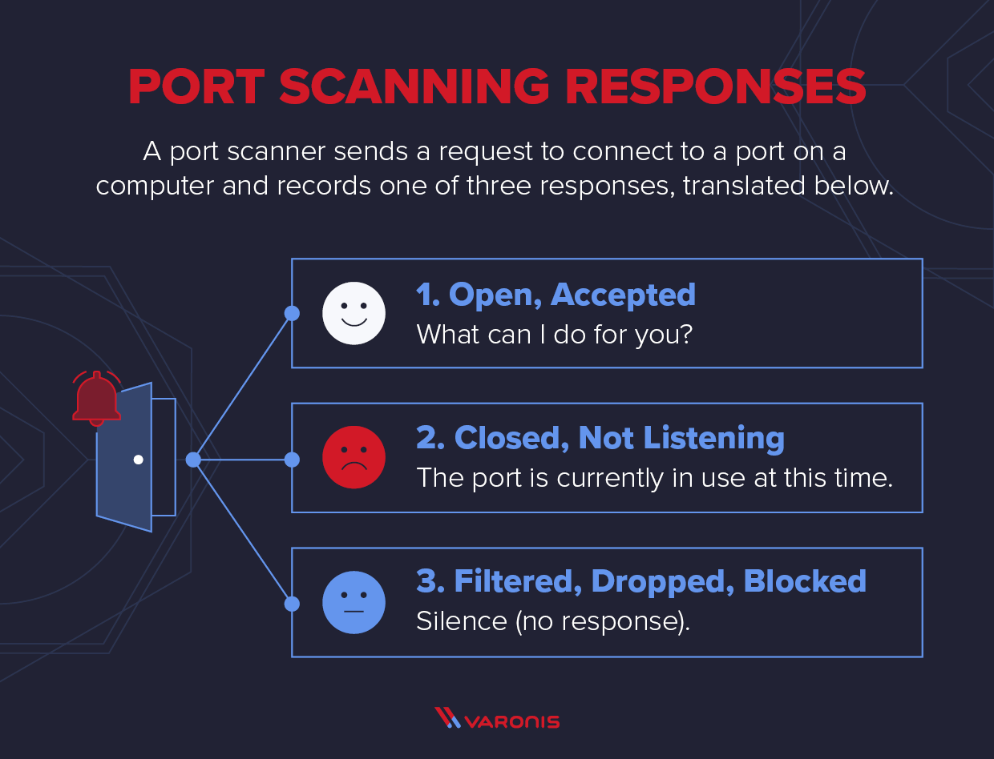
8

Objective:

- Network Mapping and Discovery: Port scanning tools aim to map and discover networked systems, including active hosts, devices, and services. This helps administrators gain insights into the network's topology and identify potential security risks.
- Vulnerability Identification: Port scanning tools assist in identifying open ports and services on target systems, allowing administrators to assess vulnerabilities associated with specific services or software versions. This helps prioritize patching and mitigation efforts to strengthen overall security.
- Penetration Testing: Port scanning tools facilitate penetration testing by simulating real-world attack scenarios and identifying potential entry points into systems or networks. This helps organizations proactively identify and address security weaknesses before they can be exploited by malicious actors.
- Firewall Rule Verification: Port scanning tools help verify firewall rules and configurations by testing the accessibility of specific ports from external and internal perspectives. This ensures that firewall policies are correctly implemented and only authorized services are accessible from intended locations.
- Intrusion Detection System: Port scanning tools can be used for intrusion detection purposes by monitoring network traffic and analyzing port scan patterns. This helps detect and alert administrators to suspicious or unauthorized scanning activities, potentially indicating a reconnaissance phase of a Cyber attack.

9

Project Scope:

The project aims to develop a robust and versatile port scanning tool to assist network administrators and Cybersecurity professionals in assessing the security posture of networked systems. The tool will provide comprehensive scanning capabilities, including network discovery, vulnerability identification, penetration testing, firewall rule verification, and intrusion detection.

10

CHAPTER TWO
Introduction:

- In the ever-evolving landscape of Cybersecurity, where digital threats loom large and vulnerabilities lurk in the shadows of complex network infrastructures, the need for robust defense mechanisms is paramount. At the heart of this defensive arsenal lies a fundamental yet powerful instrument: the port scanning tool. As technology advances and networks become increasingly interconnected, understanding the intricate anatomy of networked systems is not just advantageous but imperative for safeguarding against Cyber threats.

- Port scanning tools serve as the vanguard in this relentless pursuit of network security, offering a gateway into the intricate web of interconnected devices, services, and communication channels that constitute modern-day networks. With their ability to systematically probe and analyze the open ports on target systems, these tools unveil a treasure trove of insights, ranging from network topology and service availability to potential vulnerabilities and attack vectors.

11

Overview:

A port scanning tool is a software application designed to explore and analyze the open ports on networked systems. These tools serve as indispensable assets in the field of Cybersecurity, offering comprehensive functionalities for network reconnaissance, vulnerability assessment, penetration testing, and intrusion detection.

12

CHAPTER THREE

Methodology:
- The methodology of port scanning involves several key steps, each designed to gather information about the target environment and assess its security posture.

1. Preparation:
- Before initiating a port scan, I defined the scope of the scan, including the target IP addresses to be scanned and the scanning techniques to be employed. This step involved determining the objectives of the scan, such as network discovery, ports scanning and selecting the appropriate scanning parameters accordingly.

2. Initialization:
- Once the parameters are set, the port scanning tool establishes a connection with the target system and begins sending packets to probe the designated ports. The tool may utilize various scanning techniques, such as TCP Connect Scan, SYN Scan, UDP Scan, or Stealth Scan, depending on the user's preferences and the desired objectives of the scan.

13

3. Port Scanning Techniques:
- TCP Connect Scan: This method involves attempting to establish a full TCP connection with each target port. If a connection is successfully established, the port is considered open; otherwise, it is marked as closed or filtered.
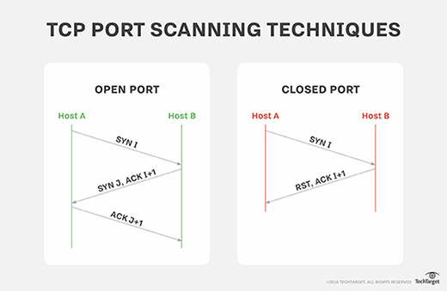

- SYN Scan: Also known as half-open scanning, this technique sends SYN packets to the target ports and analyzes their responses. Open ports typically respond with a SYN-ACK, while closed ports respond with an RST packet.
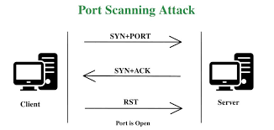

- UDP Scan: UDP scans involve sending UDP packets to target ports and analyzing responses, if any. Unlike TCP, UDP does not establish connections, making UDP scanning more challenging.

14

- Stealth Scan: This approach aims to evade detection by target systems' intrusion detection systems (IDS) or firewalls by sending packets that appear less suspicious, such as using techniques like IP spoofing or fragmentation.

4. Analysis:
- As responses are received from the target system, the port scanning tool analyzes the replies to classify each port as open, closed, or filtered. This analysis helps build a comprehensive picture of the network's service availability and potential vulnerabilities. Additionally, the tool may gather information about the services running on open ports, such as the service banner or version information.

5. Reporting:
- Upon completion of the scan, the port scanning tool generates a detailed report summarizing the findings. The report typically includes a list of open ports, identified services, and any anomalies detected during the scan. This information assists administrators and Cybersecurity professionals in making informed decisions regarding network security and remediation efforts.

6. Post-Scan Actions:
- Depending on the objectives of the scan, users may perform additional actions based on the scan results. This may include exploiting identified vulnerabilities, firewall configurations, or conducting further investigation into potential security risks.

15

CHAPTER FOUR

System Analysis and Design:

- A port scanning tool is a specialized scanning tool used in the field of Cybersecurity to explore and analyze the open ports on networked systems.
- This tool serve multiple purposes, including network scanning, port status, service running on the ports, and version of the service, by systematically probing target systems using various scanning techniques such as TCP Connect Scan, SYN Scan and UDP Scan.
- They assist network administrators, Cybersecurity professionals, and ethical hackers in understanding the security posture of networked environments, identifying potential entry points for attackers.
- It also helps in identifying active hosts, devices, and services within the network host.

16

The graphical representation of Port Scanning:

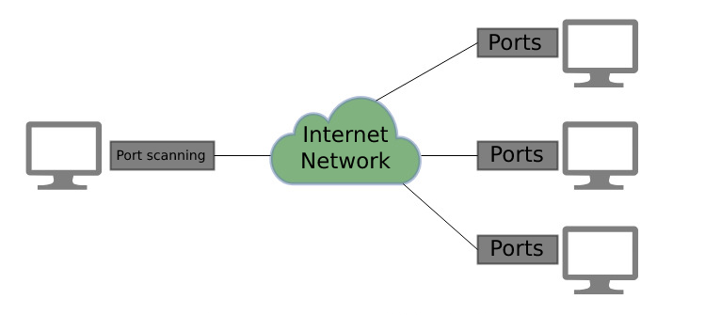

Installing:

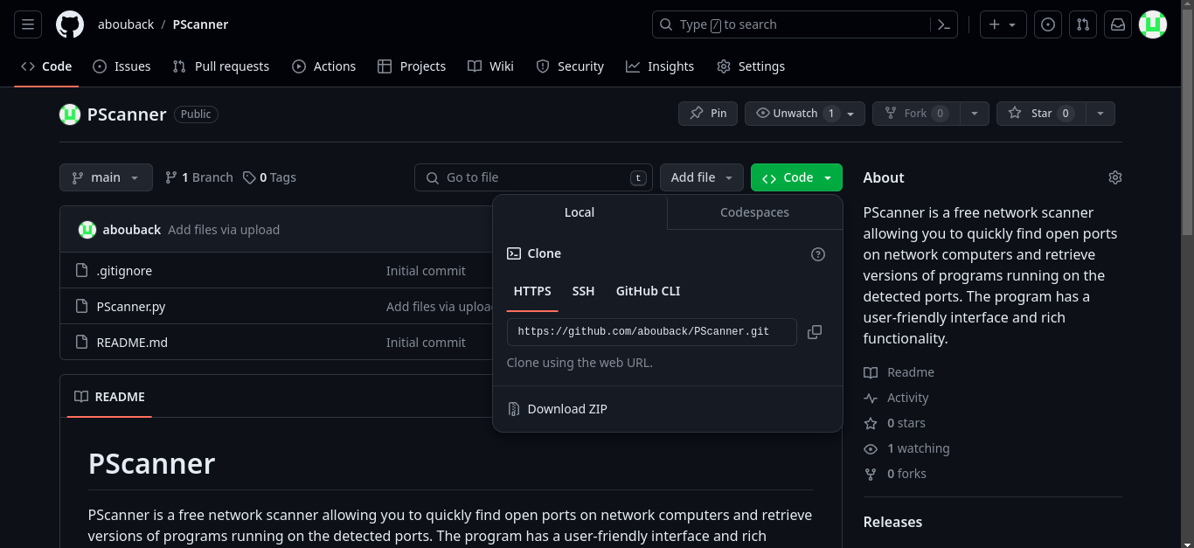

- Now let start by git cloning the port scanning tool from github
17
git clone https://github.com/abouback/PScanner.git

=> Below is the URL site where you can find the tool
https://github.com/abouback/PScanner

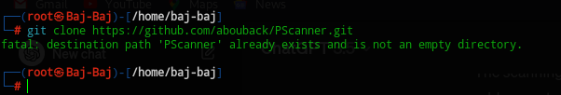

N/B:
I already have the file in my system.

- Open the directory and make sure your in the Pscanner directory so that you can run the tool.

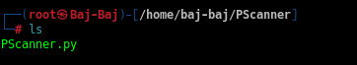

- Inside the directory, there is a python file called PScanner.py

- PScanner.py is the file which one needs to run it so that they can open the tool.

18

- To open the tool, a user should use python3 to run it.

- Lets now download the python3 package in your system:

sudo apt install python3

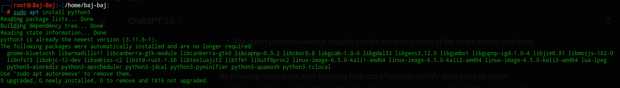

- After installing the python3 packages and installing the port scanning tool, we will now try to open a server and then run the tool to try see I it will work.
- The server which we will try to scan will be the Metasploitable3 as suggested from my trainer.
- Now lets see how I am going to open the server, see the open ports in the server, the version running in the server and how we can use the PScanner tool to scan for the open ports in the Metasploitable3 server.
- Below are the pictures and explanation for the process.

19

=> Metasploitable3 is a VM that is built from the ground up with a large amount of security vulnerabilities.
=> Metasploitable3 has been used by people in the security industry for a variety of reasons: such as training for network exploitation, exploit development, software testing, and technical job interviews.

=> Here is the first step, I started by having the the Metasploitable3 for Virtual Box, and then double clicked it so that I can open it.

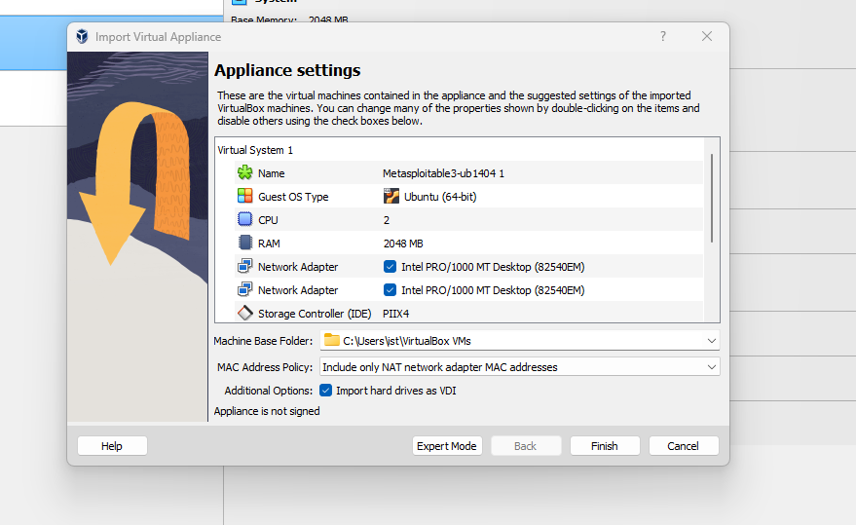

20
=> As you can see above is the picture after I clicked the Metasploitable3 is takes you directly to Virtual Box and then click finish so that it can continue the import process.



=> The importation process will start after clicking the finish button and here it will take time to import the Metasploitable3 appliances.

=> After it complete the importing process, you will then start the Metasploitable3 in the virtual box and open up.
=> Below is how it will display after you run.
=> It will ask for the login and the password and the login user will be vagrant as the password will be vagrant to.

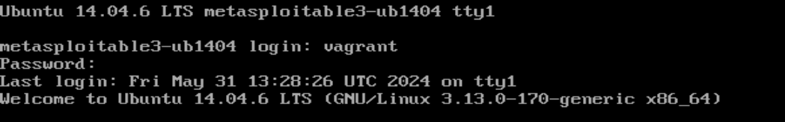

21

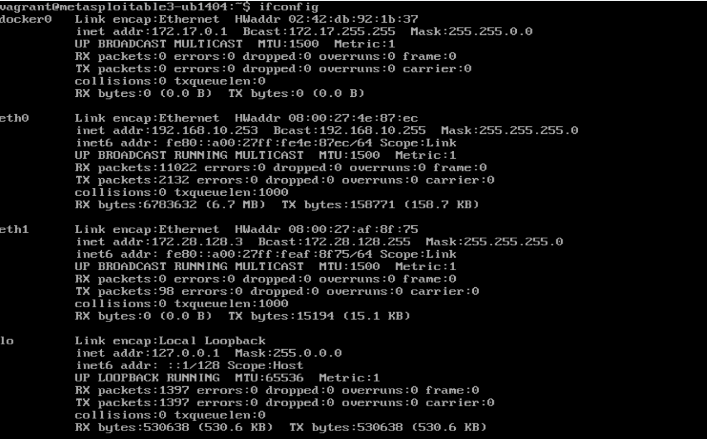
=> So here I used the command ifconfig to get the Ipaddress of the Metasploitable3 and it displayed the ipaddress, the subnet etc

=> Now I needed to find the ports which are open and see the services are running in the Metasploitable3.
=> The command I used to find for the open ports and their services which are running is netstat -tulnp and it displayed a lot of information about the ports running in the Metasploitable3.

22

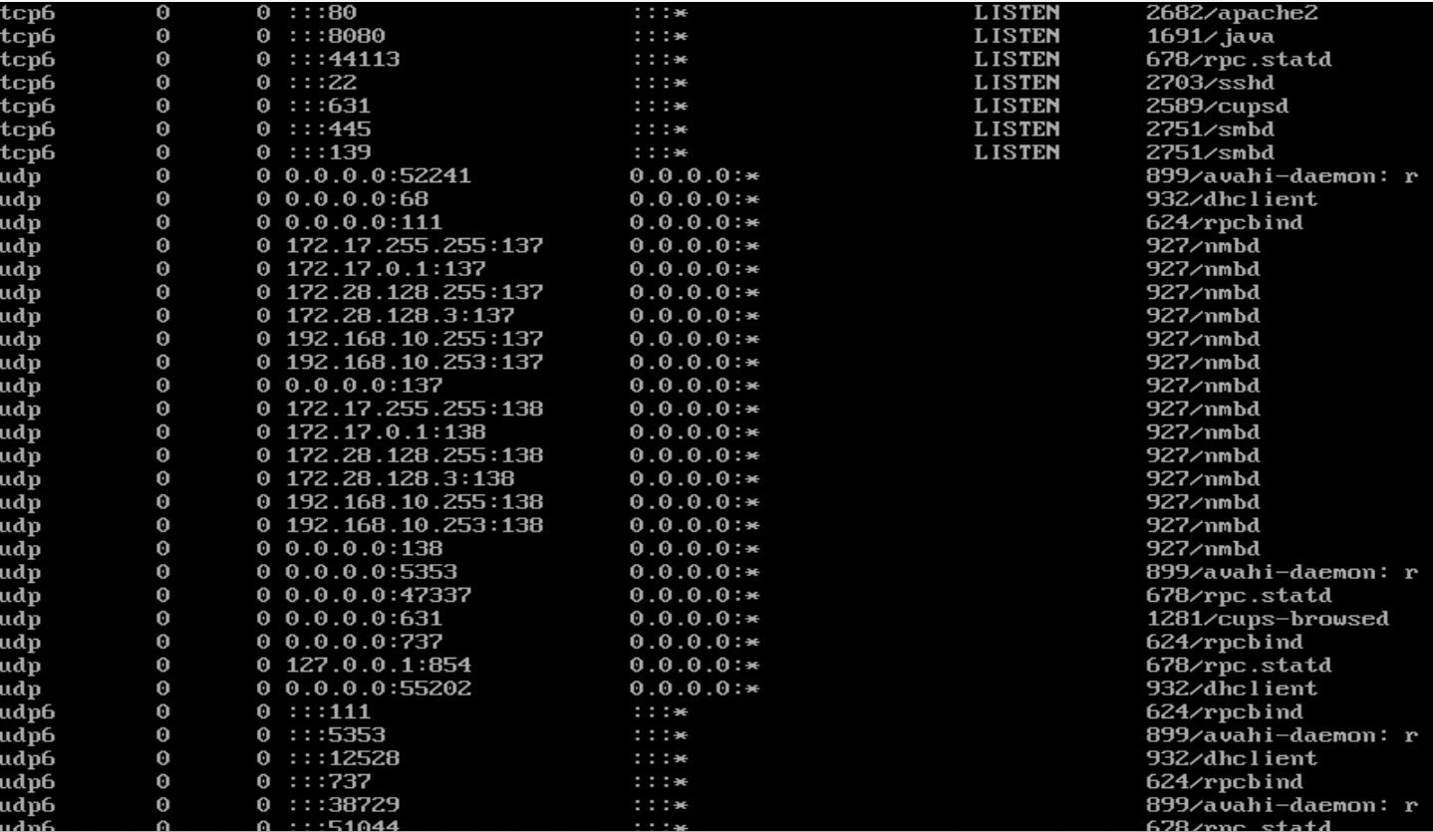

=> As you can see above there is port 80, 22, 8080, 631, 445, 139 and 44113 are all open as they are on a LISTEN mode and also it has give us the version of the ports including the apache2, ssh, smbd etc

=> I then used nmap to scan for the open ports in the Metasploitable3, so that I can confirm that how many open ports will be showed after I used tha nmap tool for scanning, and the use my port scanning tool to scan the same Metasploitable3 after confirmation.

23

=> In nmap I will use the command nmap -sV –vv + target
=> As it has displayed that when I used the ifconfig command it showed me the target at eth0 as 192.168.10.253 and this will be my Ip target.

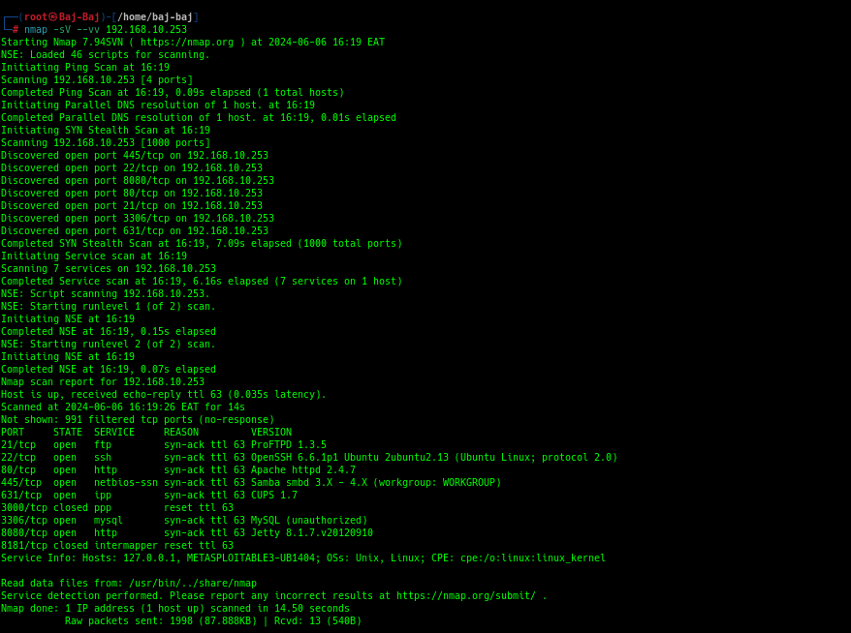
=> As we can see now in the image above is an nmap scan which has helped us to detect the open ports in the Metasploitable3, it state, service and even the version of the port open.

=> Now lets use our port scanning tool so that we can scan for the open port in the Metasploitable3 and see what result it will display.
24
=> To use the tool as I have stated in page that the tool uses a python script and we will use the python3 so that we can run the tool and it will display the results.

=> The command we can used to find for the open ports in Metasploitable3 is as follows, python3 PScanner.py + Target.

=> The PScanner.py is the tool name and the Target is the Ipaddress of the Metasploitable3 .

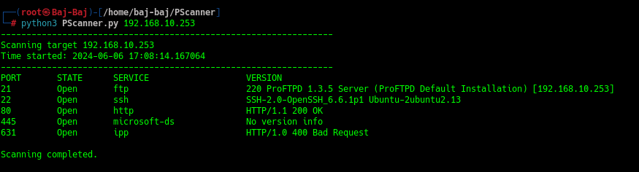

=> The image above now gives the results after I have used my port scanning tool to scan for the open ports in the Metasploitable3.

N/B:
=> As when we compared the scanning for nmap and the scanning of PScanner is that in nmap it has given us the open ports are more that 5 which giving a total sum of open ports are 7 while in PScanner has showed us the open ports scanned are 5 only.
=> This is because of the coding difference as in PScanner I have set my code script to only scan for open port starting from port 1 to port 1025 only. I hae option to change the range of the port I will want the PScanner to scan.

25
CHAPTER FIVE

Code Analysis:

#!/usr/bin/env python

import sys
import socket
from datetime import datetime

# Function to get service name for a port
def get_service_name(port):
try:
return socket.getservbyport(port)
except OSError:
return "Unknown"

# Defining our target
if len(sys.argv) == 2:
target = sys.argv[1]
try:
target_ip = socket.gethostbyname(target) # Translate hostname to IPv4
except socket.gaierror:
print(f"Hostname {target} could not be resolved.")
sys.exit()
else:
print("Invalid amount of arguments.")
print("Syntax: python3 PScanner.py <Target>")
sys.exit()

# Add a pretty banner
print("-" * 65)
print(f"Scanning target {target_ip}")
print(f"Time started: {datetime.now()}")
print("-" * 65)
26

# Add headers
print("{:<10} {:<10} {:<25} {:<30}".format("PORT", "STATE", "SERVICE", "VERSION")) # Header for the output

try:
# Scan all ports from 1 to 65535
for port in range(1, 1025): # Adjust the range for testing; use 65536 for a full scan
s = socket.socket(socket.AF_INET, socket.SOCK_STREAM)
s.settimeout(1) # Set a timeout for each connection attempt
result = s.connect_ex((target_ip, port)) # Returns an error indicator

if result == 0:
service = get_service_name(port) # Get service name
try:
s.send(b"GET / HTTP/1.0\r\n\r\n") # Send a basic HTTP request
banner = s.recv(1024) # Receive response
version = banner.split(b'\r\n')[0] # Extract version from banner
print("{:<10} {:<10} {:<25} {:<30}".format(port, "Open", service, version.decode("utf-8", errors='ignore'))) # Print port, state, service, and version
except Exception as e:
print("{:<10} {:<10} {:<25} {:<30}".format(port, "Open", service, "No version info"))
s.close()

# Exiting after finishing scanning the open ports
print("\nScanning completed.")

except KeyboardInterrupt: # Keyboard interrupt to cancel the scanning
print("\nExiting.")
sys.exit()

27

except socket.gaierror: # If the host name could not be resolved, then exit
print("Hostname could not be resolved.")
sys.exit()

except socket.error as e: # If the server could not connect, then exit
print(f"Could not connect to server: {e}")
sys.exit()

28
Code Analysis Images

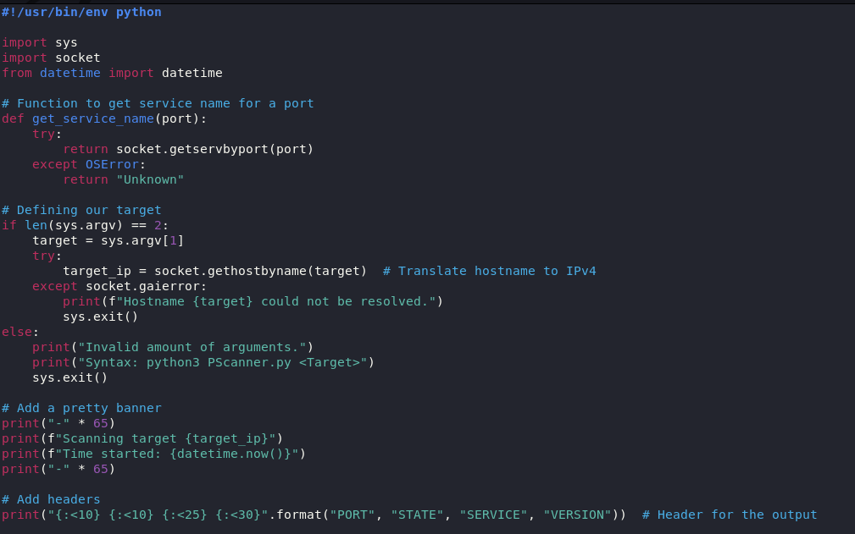
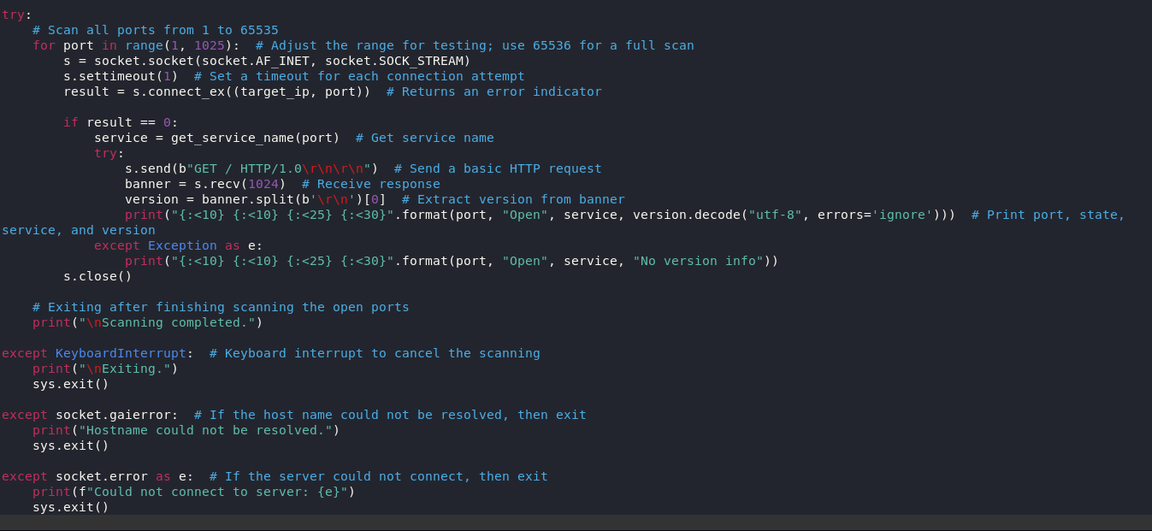

29

SUMMARY:

- A port scanning tool is a specialized software application used in the field of Cybersecurity to explore and analyze the open ports on networked systems. These tools serve multiple purposes, including network reconnaissance, vulnerability assessment, penetration testing, and intrusion detection.
- By systematically probing target systems using various scanning techniques such as TCP Connect Scan, SYN Scan, UDP Scan, and Stealth Scan, port scanning tools provide valuable insights into network topology, service availability, and potential security vulnerabilities.
- They assist network administrators, Cybersecurity professionals, and ethical hackers in understanding the security posture of networked environments, identifying potential entry points for attackers, and mitigating Cyber threats effectively.
- With features for user-friendly configuration, detailed reporting, and scalability, port scanning tools play a crucial role in safeguarding digital assets and maintaining a robust defense against malicious actors in today's interconnected world of technology.

30

REFERENCES

Author(s): Abubakar. A. A

Year: 2024

Title: PScanner: Port Scanning Tool Documentation

Version: 5.1.0

Publisher: Abubakar Abdallah Abubakar

URL: https://github.com/abouback/PScanner

31

